MobileSprite User Guide

Version: 1.0.6
E-TOOLS-ALL-UG-2011-0001
Date: 2012-02-07


www.spreadtrum.com
Import Notice
Copyright Notice
Copyright © 2011, Spreadtrum Communications, Inc. All rights reserved.
Trademarks
Spreadtrum Communications, Inc. and Spreadtrum Communications, Inc.'s products are exclusively owned by Spreadtrum Communications, Inc. References to other companies and their products use trademarks owned by the respective companies and are for reference purpose only.
Warranty Disclaimer
Spreadtrum Communications, Inc. makes no representations or warranties, either expressed or implied, by or with respect to anything in this document, and shall not be liable for any implied warranties of merchantability or fitness for a particular purpose or for any indirect, special or consequential damages.
Confidentiality
The information contained herein (including any attachments) is confidential. The recipient hereby acknowledges the confidentiality of this document, and except for specific purposes, this document shall not be disclosed to any third party.
About This Document
Purpose
The MovieEncodeUser Guide describes how to use MovieEncode。
Reader
This document just suit all user
Introduction
This Document include two chapters：
- Chapter1：Tool Introduction；
- Chapter2：User operation；
Document Convention
Pls pay attention to below sign.
Notice：
Notice things.

Explain：
Explain important things.

Contents
第1章 Introduction 1-1
1.1 Purpose 1-1
1.2 Input file 1-1
1.3 Output file 1-1
第2章 Basic Operations 2-1
2.1 Run application 2-1
2.1.1 Setup 2-1
2.1.2 Run application 2-6
2.2 Using MovieEncode 2-7
附录A Revision History 2-14

Introduction

Purpose
MovieEncode is used to convert mp4/AVI/RMVB movies to kmv file.and the kmv file can played in mobile.

Input file
  - Support OS：Windows XP/2000/Win7/Vistar x86/64 OS
  - Support movie’s format：320x240/ Constant Frame Rate/mp4/avi/rmvb Visual/AAC/AC-3

Output file
Output file：
*.kmv (320x?/15 fps/KMV)
*.smv (320x240/352*288/SMV)

Basic Operations

Run application

Setup
Must using administrator accounts and run MovieEncode Setup.exe.about the install directory, don’t suggest to put in os directory.other options,you can use default data..
Notice：
- Must using administrator accounts to install application，the setup directory is not same as os’s directory only when your pc just have one disc，
- when your pc just have one disc，other options can be select default data during installing
- running this tool on x86 os is better.
- if your pc had been installed AviSynth，AVSLib，Vcredist and K-Lite Codec Pack parts，you can igore them.just setup MovieEncode.

Launch MovieEncode Setup.exe ,select MovieEncode install directory, reference（notice 1 and 2）：
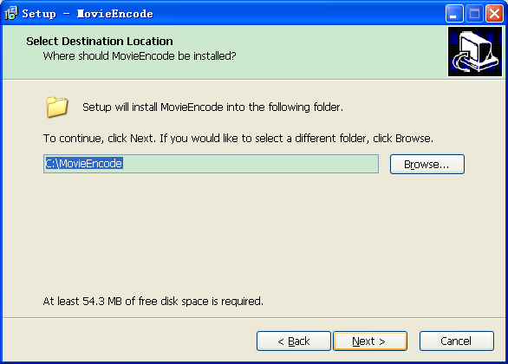

Install AviSynthpart，select AviSynth install directory ，reference（notice 1 and 2）, （if it had been installed ago，you can click cancel button）

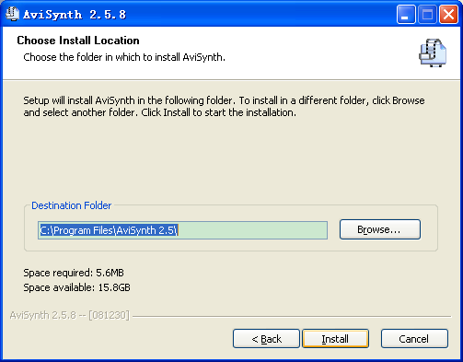

Install AVSLib，select AVSLib install directory，reference（notice 1 and 2）, （if it had been installed ago，you can click cancel button）
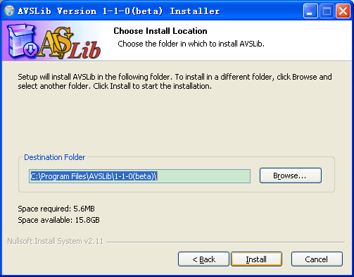

Install Vcredist，if your pc had been installed it ，you can select “Repair”mode。（if it had been installed ago，you can click cancel button）

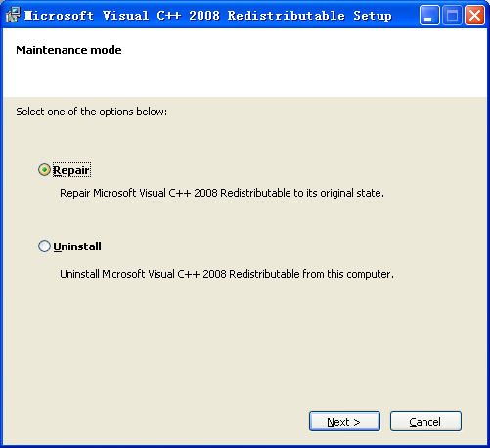

Install K-Lite Codec Pack，select K-Lite Codec Pack install directory，reference（notice 1 and 2）, （if it had been installed ago，you can click cancel button）

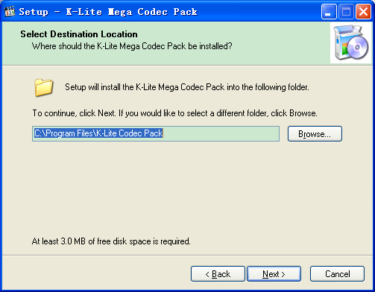

Run application
Run MovieEncod’s shortcut on desktop or launch it on startmenu.,main UI as belowe：
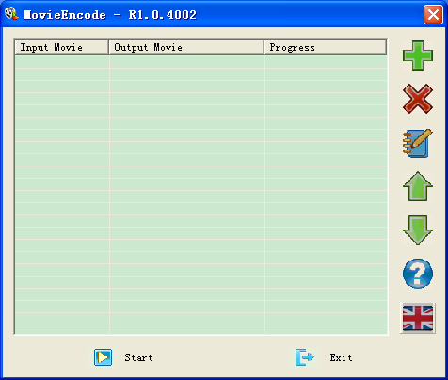
图 2-1 main UI

Using MovieEncode
1.Click“+”button to entry setting window，please select source movie on“input movie”,just suppor mp4/AVI/rmvb format’s movie，User can set some parameter on this seting window。
Parameter include movie setting ,watermark setting and story setting。
  - movie setting include default and user mode. In default option, fine data is movie and the caption detect is bottom caption In the user mode option, user can select some parameter。
1.1.1 Fixed size：user can select output movie’s width and height。
1.1.2 Dynamic Size：output movie’s width and height ratio is same as source movie, you select a width data,then it will auto calculate a height。
1.1.3 F_Ratio： user can select to input baudratio.
1.1.4 Output SMV：then will output smv format movie,，and it will support mp4/avi/rmvb/kmv
1.1.5 Output HMV:then will oupt hmv format movie,and it will support mp4/avi/rmvb source movie.
Suggestted using 320x240 size for 6620 platform and 640x480 size for 6800 series platform.
Notice:
- If you want to convert 3D movie，So suggested to select high data in F_ratio option

  - Watermark seting part, User can select to add watermark ,or not. When this function will be selected,user can select watermark’s photo , transparency and watermark’s site.
Notice：
About watermark’s photo, it must be a bmp file. This bmp file must accord with Width is 40 pixels, Heigth is 32 pixels and it is 24 bits .If user don’t use specified bmp file ,and movieencode application will auto convert it to specified bmp file,but don’t ensure picture’s quality， So suggested art designing to make specified photo.

1.3 Story setting include movie Cover，movie name，movie length ，movie years，categoryType，actor andMovie intro parts。
I. Movie Cover：Support bmp，jpg，gif,tiff and png pictures，if the pictureformat is not 81*64 bmp file, then tool will auto convert it to 81*64 bmp picture。
II. Movie Name：no more than 60 characters。
III．Movie length：1 ~ 999 minutes。
IV. Movie year：1900 ~ 2099。
V.Movie actor：no more than 100 characters。
VI.Movie Intro：no more than 250 characters。

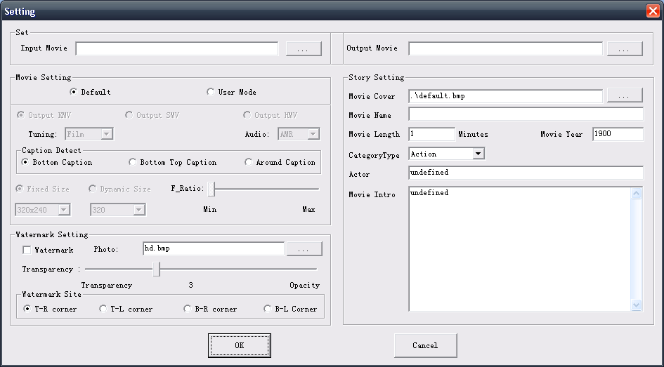
图 2-2 设置界面
- When user complete some setting, click OK button to confirm next action.
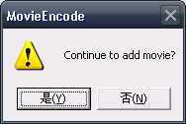
图 2-3 确认界面
Explain some info as below:：
A.below info prompt user select movie cover.，default is default.bmp。
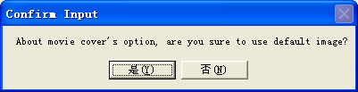
B. Below info prompt user should be input correct movie length data（movie length is from 1 to 999 minutes）.
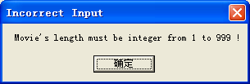
B.Below info prompt user should be input correct movie year（movie year is from 1900 to2099）。
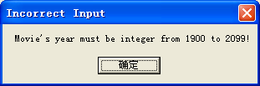

- Click Start button ,then tool will auto convert your movies to kmv file. tool will show “Success” afte r accurately converted.

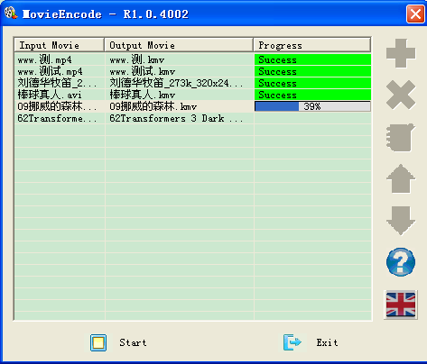
图 2-4 转换中
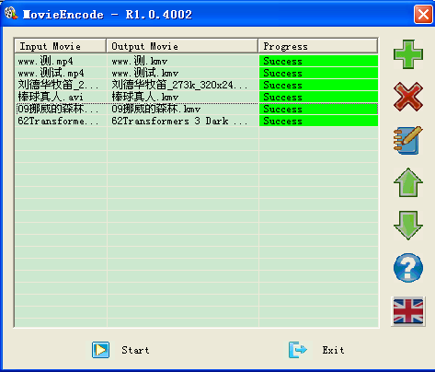
图 2-4 转换结束
Notice1：
If you install this tool on your os directory.
A.if os is win XP/2000,you must use administrator accounts to run MovieEncode，otherwise it will show X264 error as below。
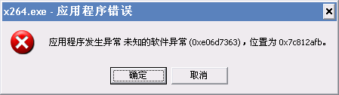
B．if os is win7/vistar，please select MovieEncode’s shortcut，select “administator” option in right-hand button.
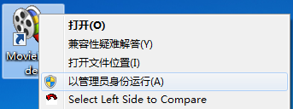
2.if this tool install directory is not same as os directory,you don’t worry it .
3.this tool don’t suppot less than 320*240 movie’s transition.

Notice 2：
Due to this tool using K_Lite_Codec during converting, but this video decoder and camera shooting isn’t compatible, but you can follow below setting to resolve that issue.
Step 1：Open ffdshow video decpder setting dialog on start menu and selected Directshow control option.
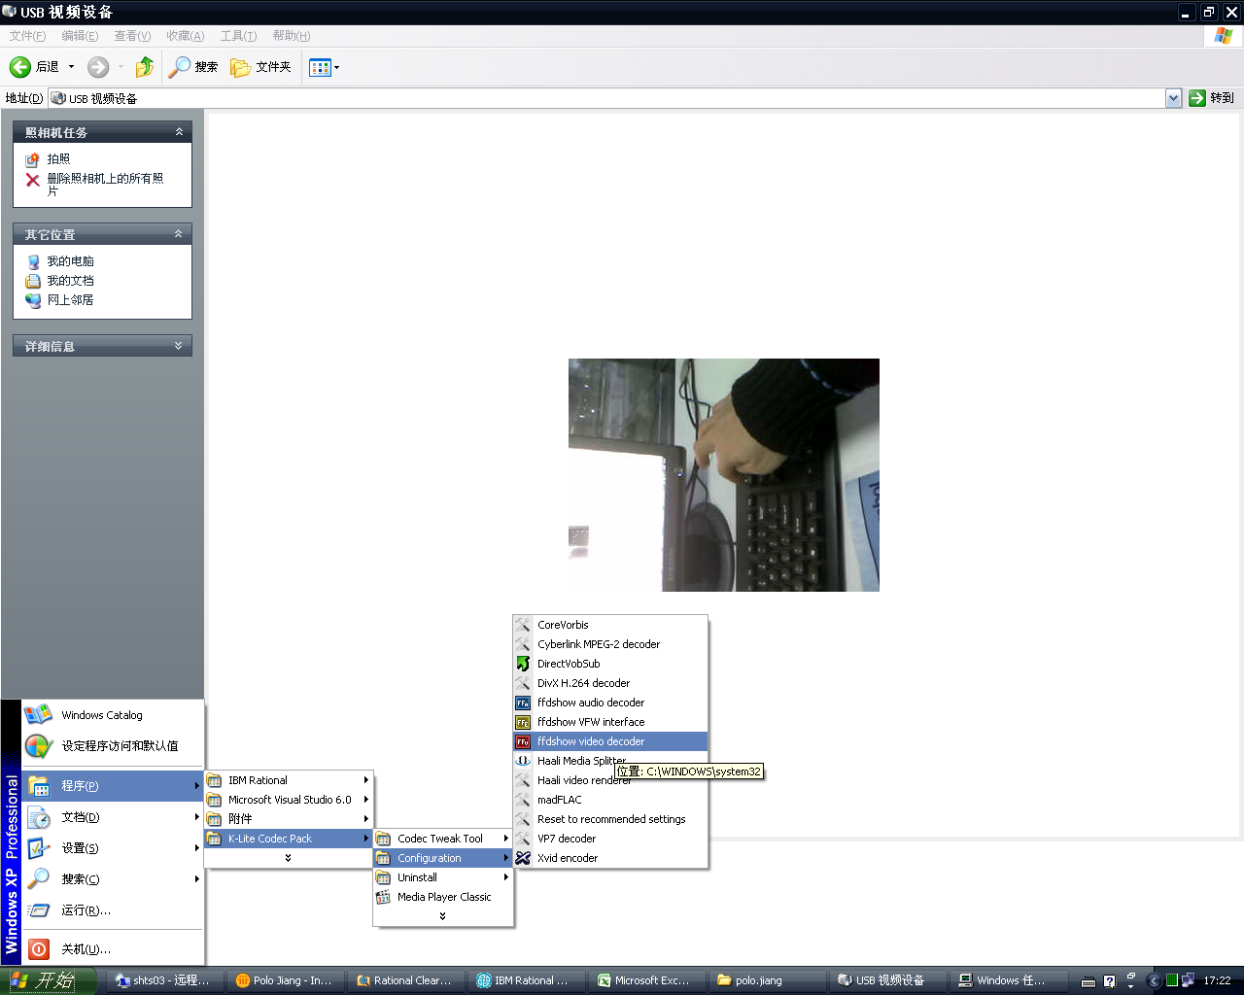
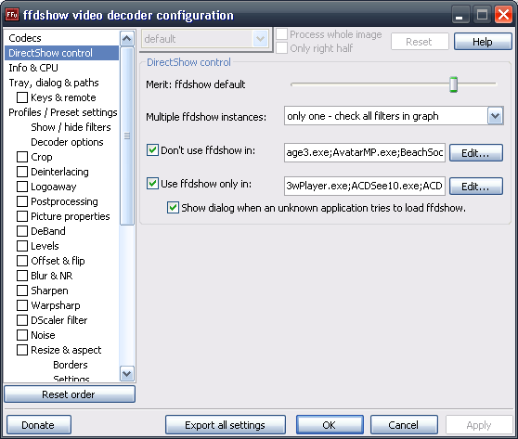
Step2：Click “Don’t use ffdshow in”option’s EDIT button，After please added your camera shooting client software in directshow list.
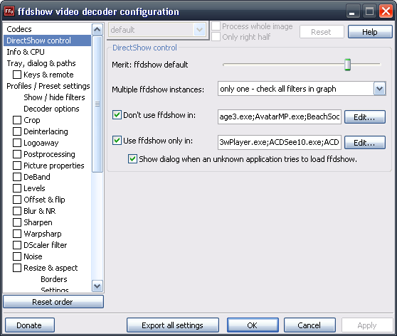
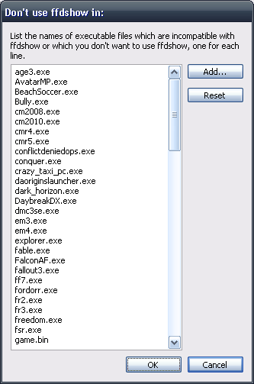
Step3:Save your new setting, then will resolve this issue.

Revision History
Version | Date | Owner | Notes
1.0.1 | 2011-10-26 | Polo.jiang | Created
1.0.2 | 2011-11-18 | Polo.jiang | Addded Watermark function
1.0.3 | 2011-12-01 | Polo.jiang | Addded Watermark transparency and aac audio
1.0.4 | 2011-12-21 | Polo.jiang | Addded support smv
1.0.5 | 2012-01-18 | Polo.jiang | Addded support hmv
1.0.6 | 2012-02-07 | Polo.jiang | Remove Quality option in UI

